|  |  |  |  |  |  |
| --- | --- | --- | --- | --- | --- |
| **Test No.** | **Test Data/Action** | **Reason/Explanation** | **Test type** | **Expected Result** | **Actual Result** |
| 1 | Does the user see the Upload Button on launch? | User needs to see the Upload button to be able to import images into the program. | Typical | Button should be visible. | Pass  (Test 1) |
| 2 | Does the zoom Indicator change with the usage of the zoom buttons | The zoom indicator is meant to help the user with seeing how far zoomed they are. | Typical | Zoom indicator should double when the “+” button pressed, and halve when “-“ button pressed | Pass  (Test 2) |
| 3 | Does the Price Conversion box accept negative | The price should never be a string | Erroneous | The price conversion should not allow me to put in a string, nothing should show | Pass (doesn’t allow me to enter string) |
| 4 | Clicking shape button. | User can create the shape by pressing the button | Typical | A rectangle should appear on screen. | Pass (Rectangle appears) (Test 3) |
| 5 | Clicking and dragging the circle at the side of a rectangle. | This should resize the shape. | Typical | The shape should increase in width when dragging right. | Pass (Test 4) |
| 6 | Clicking a rectangle | This should show custom layer buttons on the side. As the layer is selected. | Typical | Should show the colour buttons, layer up and down buttons + more. | Pass (Test 5) |
| 7 | Clicking off a rectangle | This should deselect the layer | Typical | Should hide the Buttons on the right side and box around the rectangle is hidden. | Pass (Test 6) |

**List of Tests**

1. 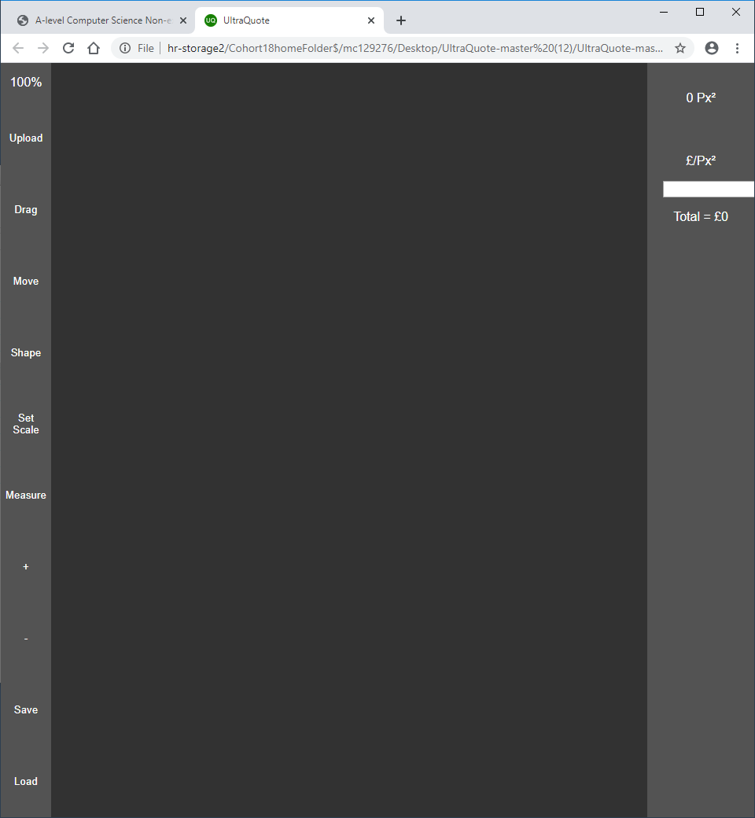
2. 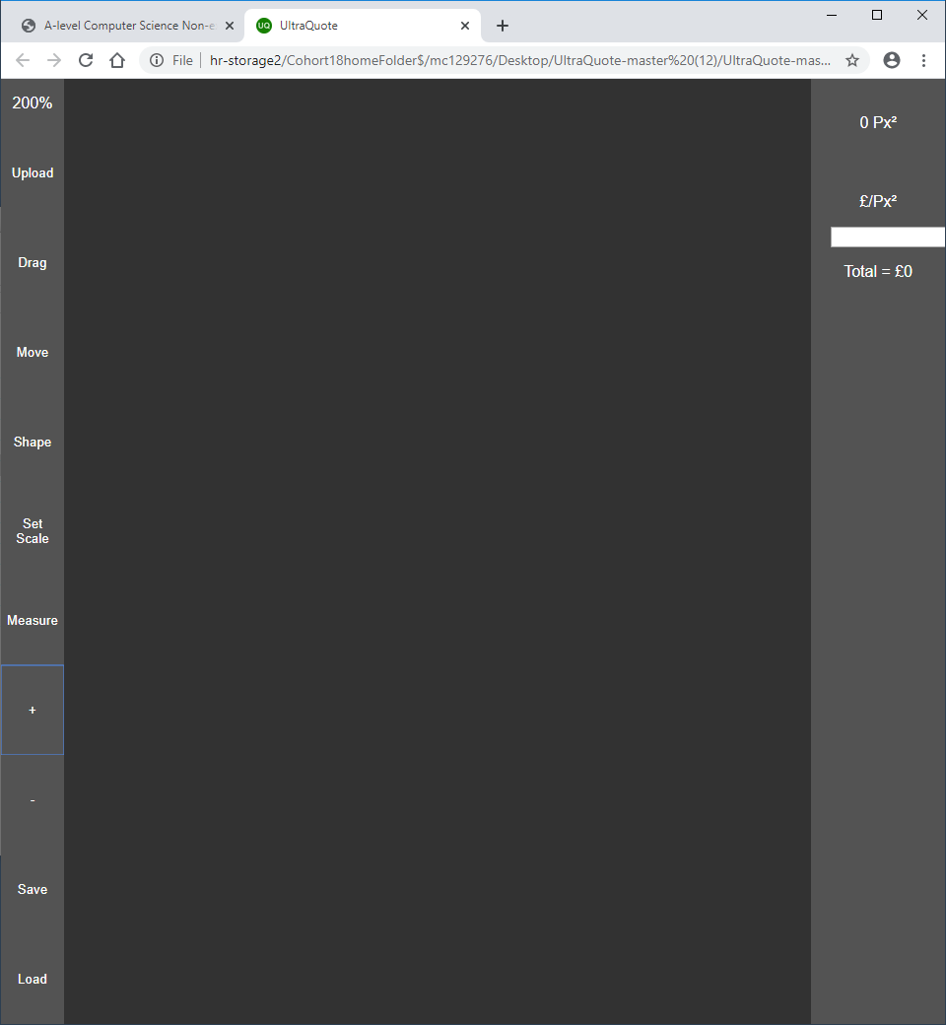
3. 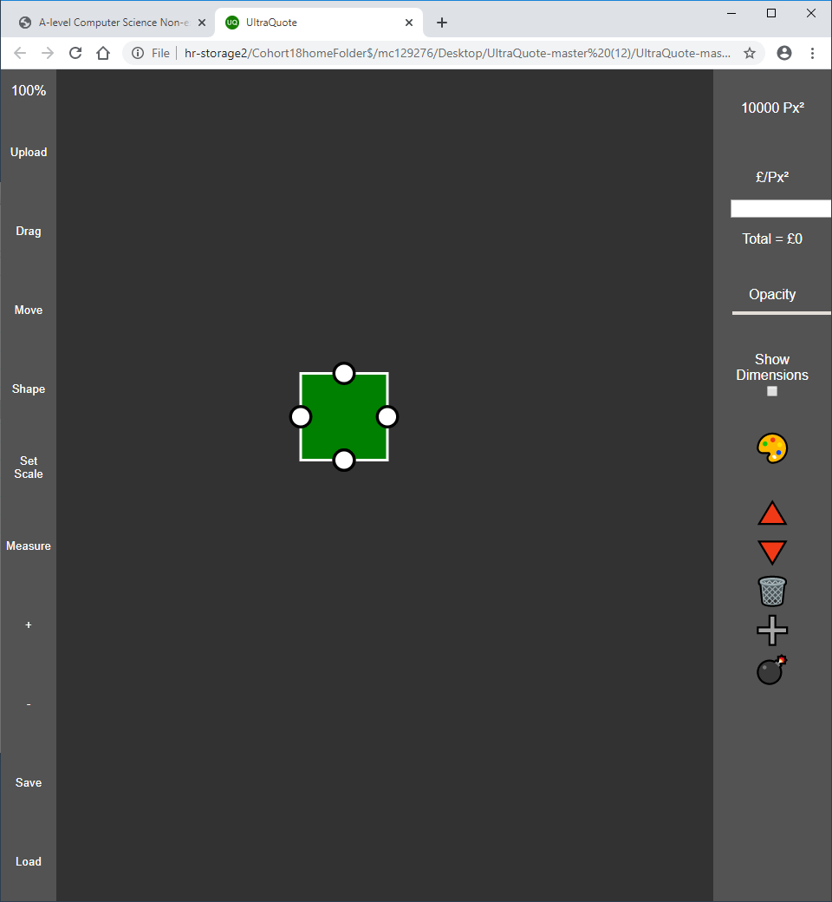
4. 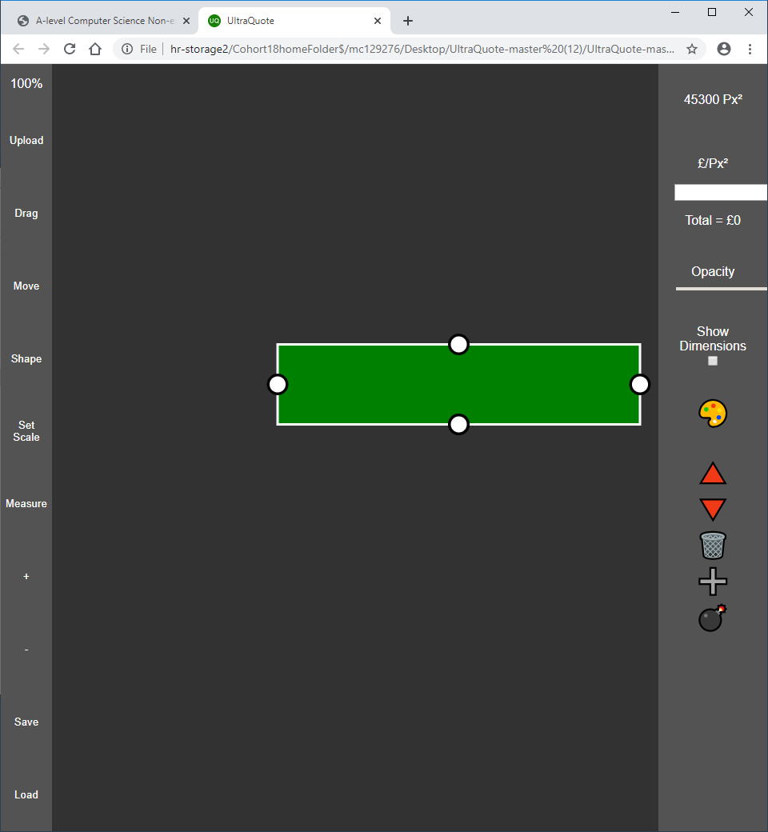
5. 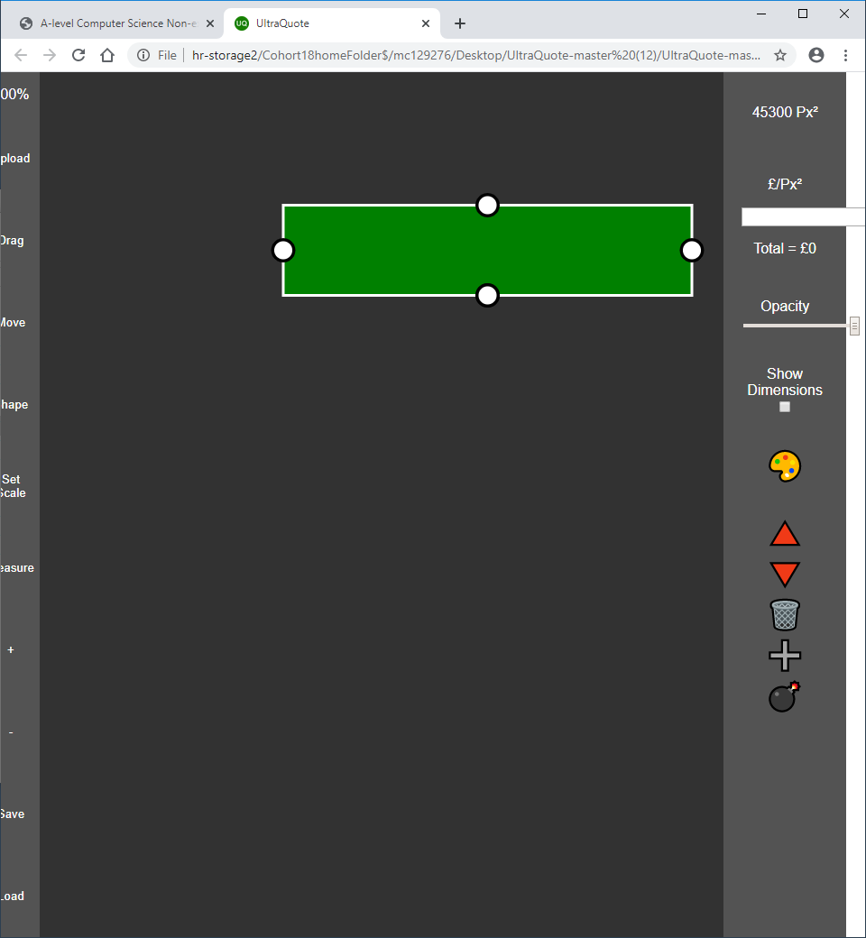
6. 